Q.1. Write a Java Program to find GCD of two given numbers.

//WAP to find GCD of two given numbers.

import java.util.\*;

public class A1Q1

{

public static void main(String[] args)

{

Scanner s = new Scanner(System.in);

System.out.print("Enter the 1st number:");

int a = s.nextInt();

System.out.print("Enter the 2nd number:");

int b = s.nextInt();

int gcd = gcd(a,b);

System.out.print("The gcd of two numbers "+a+", "+b+" is: "+gcd);

}

static int gcd(int a, int b)

{

if (a == 0)

return b;

return gcd(b % a, a);

}

}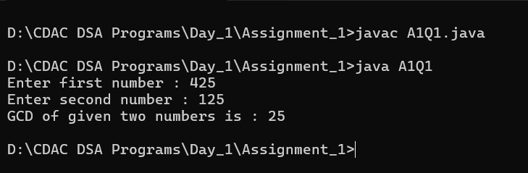

Q.2. Write a java program to LCM of TWO given number.

//WAP to find LCM of two given numbers.

import java.util.\*;

import java.io.\*;

public class A1Q2

{

public static void main(String[] args) {

Scanner s = new Scanner(System.in);

System.out.print("Enter the 1st number:");

int a = s.nextInt();

System.out.print("Enter the 2nd number:");

int b = s.nextInt();

int lcm = calculateLCM(a,b);

System.out.print("The LCM of two numbers "+a+", "+b+" is: "+lcm);

}

static int gcd(int a, int b)

{

if (a == 0)

return b;

return gcd(b % a, a);

}

static int calculateLCM(int a, int b)

{

return (a / gcd(a, b)) \* b;

}

}

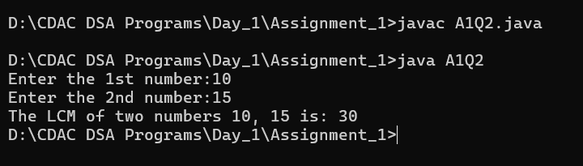

Q.3. Write a Java Program to print all the Prime Factors of the Given Number.

//WAP to print all the Prime Factors of the Given Number.

import java.util.\*;

import java.io.\*;

public class A1Q3 {

static void factors(int n, int i)

{

if (i <= n) {

if (n % i == 0) {

System.out.print(i + " ");

}

factors(n, i + 1);

}

}

public static void main(String[] args){

Scanner s = new Scanner(System.in);

System.out.print("Enter number to print its prime fators :");

int a = s.nextInt();

int b = 1;

factors(a,b);

}

}

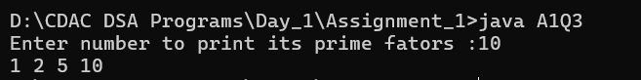

Q.4. Check whether the Given Number is a Palindrome or NOT.

//WAP to check if it is palindrome or not .

import java.util.\*;

import java.io.\*;

public class A1Q4{

static int rev(int n, int temp) {

if (n == 0)

return temp;

temp = (temp \* 10) + (n % 10);

return rev(n / 10, temp);

}

public static void main(String[] args) {

Scanner s = new Scanner(System.in);

System.out.print("Enter number to check if it is palindrome or not :");

int a = s.nextInt();

int b = 0;

int pal = rev(a,b);

if (pal == a)

System.out.println("yes");

else

System.out.println("no" );

}

}

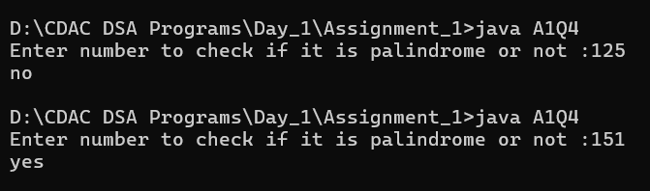

Q.5. Write a Java Program to check whether the Given Number is Prime Number or NOT.

//WAP to check if it is palindrome or not .

import java.util.\*;

import java.io.\*;

public class A1Q5 {

static boolean isPrime(int n, int i) {

if (n <= 2)

return (n == 2) ? true : false;

if (n % i == 0)

return false;

if (i \* i > n)

return true;

return isPrime(n, i + 1);

}

public static void main(String[] args) {

Scanner s = new Scanner(System.in);

System.out.print("Enter number to check if it is palindrome or not :");

int a = s.nextInt();

int b = 2;

if (isPrime(a,b))

System.out.println(a + " is a prime number");

else

System.out.println(a + " is not a prime number" );

}

}

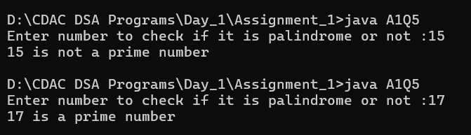

Q.6. Write a Java Program to check whether the given number is Armstrong Number or NOT.

//WAP to check if it is Armstrong or not.

import java.util.\*;

import java.io.\*;

public class A1Q6 {

public static boolean isArmstrong(int number) {

if (number == 0) {

return true;

}

int sum = 0;

int digit = number % 10;

sum += digit \* digit \* digit;

number /= 10;

return isArmstrong(number) && sum == number;

}

public static void main(String[] args) {

Scanner sc = new Scanner(System.in);

System.out.print("Enter number to check if it is Armstrong or not :");

int a = sc.nextInt();

if (isArmstrong(a))

System.out.println(a + " is a Armstrong number");

else

System.out.println(a + " is not a Armstrong number" );

}

}

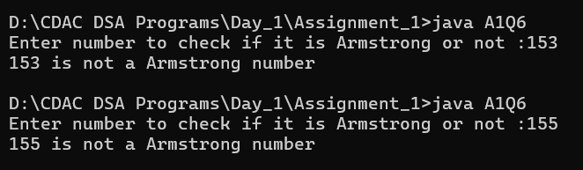

Q.7. Write a Java Program to check whether the given number is Perfect Number or NOT.

//WAP to check if it is perfect or not .

import java.util.\*;

import java.io.\*;

public class A1Q7

{ static boolean isPerfect(int n) {

if (n == 1)

return false;

int sum = 1;

for (int i = 2; i < n; i++) {

if (n % i == 0) {

sum += i; } }

if (sum == n)

return true;

return false; }

public static void main(String[] args) {

Scanner sc = new Scanner(System.in);

System.out.print("Enter number to check if it is perfect or not :");

int a = sc.nextInt();

if (isPerfect(a))

System.out.println(a + " is a perfect number");

else

System.out.println(a + " is not a perfect number");

} }

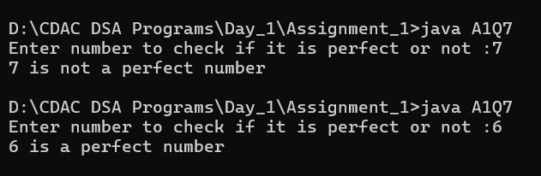

Q.8. Write a Java Program to check whether the given numbers are Amicable Numbers or NOT.

//WAP to check whether the given numbers are Amicable Numbers or NOT.

import java.util.\*;

import java.io.\*;

public class A1Q8 {

public static int sumOfDivisors(int num, int i) {

if (i == 1) { return 1; }

if (num % i == 0) {

return i + sumOfDivisors(num, i - 1);

} else { return sumOfDivisors(num, i - 1); } }

public static boolean isAmicable(int num1, int num2) {

return num1 != num2 && sumOfDivisors(num1, num1 / 2) == num2 && sumOfDivisors(num2, num2 / 2) == num1; }

public static void main(String[] args) {

Scanner sc = new Scanner(System.in);

System.out.print("Enter the first number : ");

int num1 = sc.nextInt();

System.out.print("Enter the second number: ");

int num2 = sc.nextInt();

if (isAmicable(num1, num2)) {

System.out.println(num1 + " and " + num2 + " are amicable numbers.");

} else { System.out.println(num1 + " and " + num2 + " are not amicable numbers."); } } }

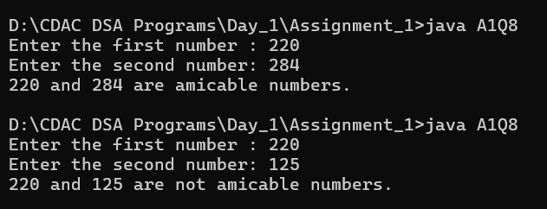

Q.9. Write a Java Program to check whether the given number is Ramanujam's Number or NOT.

//WAP to check whether the given number is Ramanujam's Number or NOT.

import java.util.\*;

import java.io.\*;s

public class A1Q9

{

public static boolean isRamanujamNumber(int num, int a, int b, int c) {

if (num == 0) {

return false; }

if (a \* a \* a + b \* b \* b == num) {

return true; }

if (a \* a \* a + b \* b \* b > num) {

return false; }

return isRamanujamNumber(num, a + 1, b, c); }

public static void main(String[] args) {

Scanner scanner = new Scanner(System.in);

System.out.print("Enter a number to check if it's a Ramanujam number: ");

int number = scanner.nextInt();

if (isRamanujamNumber(number, 1, 1, 1)) {

System.out.println(number + " is a Ramanujam Number.");

} else {

System.out.println(number + " is not a Ramanujam Number.");

}

}

}

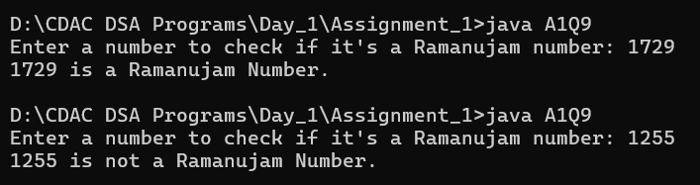

Q.10. Write a Java Program check whether the given number is Automorphic Number or NOT.

//WAP to check whether the given number is Automorphic Number or NOT.

import java.util.\*;

import java.io.\*;

public class A1Q10 {

public static boolean isAutomorphic(int number) {

if (number == 0) {

return true; }

int square = number \* number;

int lastDigitOfSquare = square % 10;

int lastDigitOfNumber = number % 10;

if (lastDigitOfSquare != lastDigitOfNumber) {

return false; }

return isAutomorphic(number / 10); }

public static void main(String[] args) {

Scanner sc = new Scanner(System.in);

System.out.print("Enter number to checck Automorphic Numberor : ");

int number = sc.nextInt();

if (isAutomorphic(number)) {

System.out.println(number + " is an automorphic number.");

} else {

System.out.println(number + " is not an automorphic number.");

} } }

